

Laboratory Report

Course ID: CPS 2390
Lab 1: A Simple LC-3 Program

Student: Thomas Yamakaitis

Instructor: Dr. Jing-Chiou Liou

Date: 10/11/2016
Description
The purpose of this lab was to show us how to use the LC-3 program and gives a hands on experience using the instructions. It also gave us a look into creating algorithms for a program. The goal was to be able to check if any given number is even or odd, and to count the 1’s in the binary version of any given number.
Procedure and Notes
- In order to make it a bit easier, I separated the lab into two parts, Lab 1A and Lab 1B.
- Lab 1A is the part where we check if the number is even or odd. I used a masking algorithm that would return the least significant bit which if it is 1, it is odd, or if it is 0, it is even.
- Lab 1B is the part where we count the number of 1’s in the binary number. I used the “Hamming Weight” algorithm which you can find more details on here: https://en.wikipedia.org/wiki/Hamming_weight
- I had difficulty implementing the Hamming Weight algorithm, but I figured it out. I still have a hard time explaining it.

Results and Reports
Lab 1A: Even/Odd
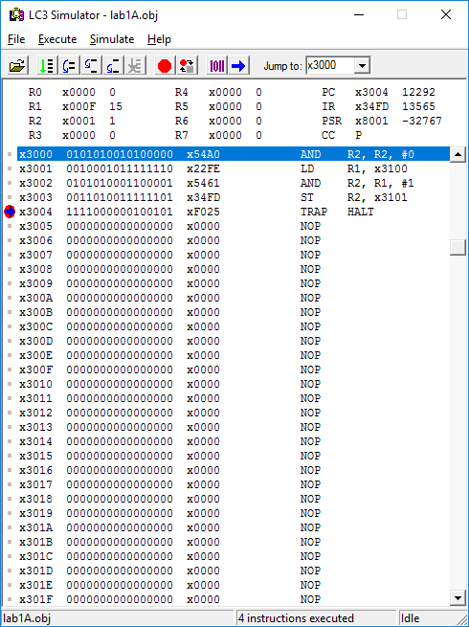
Lab 1B: Counting 1’s
